**[C#设计模式--简单工厂模式](https://www.cnblogs.com/JiYF/p/6405359.html)**

**设计模式：**

**简单工厂模式（Simple Factory Pattern）**

介绍：简单工厂模式不是Gof23种设计模式之一。但它在实际的编程中经常被用到，而且思想也非常简单，下面简单举例说明：

简单工厂模式类图：

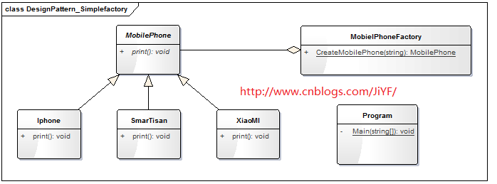

**简单工厂模式C#代码举例：**

**MobilePhone（手机类）**

1 public abstract class MobilePhone

2 {

3

4 public abstract void print();

5 }

**Iphone（苹果手机类）**

[复制代码](javascript:void(0);)

1 public class Iphone : MobilePhone

2 {

3

4 public override void print()

5 {

6 Console.WriteLine("我是苹果品牌！");

7 }

8 }

[复制代码](javascript:void(0);)

**XiaoMI（小米手机类）**

[复制代码](javascript:void(0);)

1 public class XiaoMI : MobilePhone

2 {

3 public override void print()

4 {

5 Console.WriteLine("我是小米手机");

6 }

7 }

[复制代码](javascript:void(0);)

**SmarTisan（锤子手机类）**

[复制代码](javascript:void(0);)

public class SmarTisan : MobilePhone

{

public override void print()

{

Console.WriteLine("我是锤子手机！");

}

}

[复制代码](javascript:void(0);)

**MobielPhoneFactory（手机工厂类）**

[复制代码](javascript:void(0);)

1 public class MobielPhoneFactory

2 {

3 public static MobilePhone CreateMobilePhone(string PhoneBrand)

4 {

5 MobilePhone mobilePhone = null;

6 if (PhoneBrand.Equals("苹果"))

7 {

8 mobilePhone = new Iphone();

9 }

10 else if (PhoneBrand.Equals("小米"))

11 {

12 mobilePhone = new XiaoMI();

13 }

14 else if (PhoneBrand.Equals("锤子"))

15 {

16 mobilePhone = new SmarTisan();

17 }

18 else

19 {

20

21 }

22 return mobilePhone;

23 }

24

25 }

[复制代码](javascript:void(0);)

**测试工厂代码：**

[复制代码](javascript:void(0);)

1 class Program

2 {

3 static void Main(string[] args)

4 {

5 MobilePhone mobilephone1 = MobielPhoneFactory.CreateMobilePhone("苹果");

6 if(mobilephone1 != null)

7 mobilephone1.print();

8 MobilePhone mobilephone2 = MobielPhoneFactory.CreateMobilePhone("小米");

9 if(mobilephone2 != null)

10 mobilephone2.print();

11 MobilePhone mobilephone3 = MobielPhoneFactory.CreateMobilePhone("锤子");

12 if(mobilephone3 != null)

13 mobilephone3.print();

14 Console.Read();

15 }

16 }

[复制代码](javascript:void(0);)

**运行结果：**

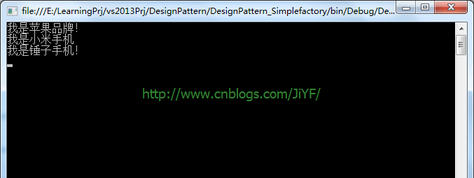

**总结：如有问题欢迎留言！以上便是一个简单工厂模式！**

[**代码工程文件下载**](http://files.cnblogs.com/files/JiYF/DesignPattern.rar)